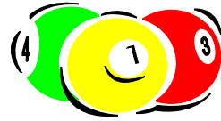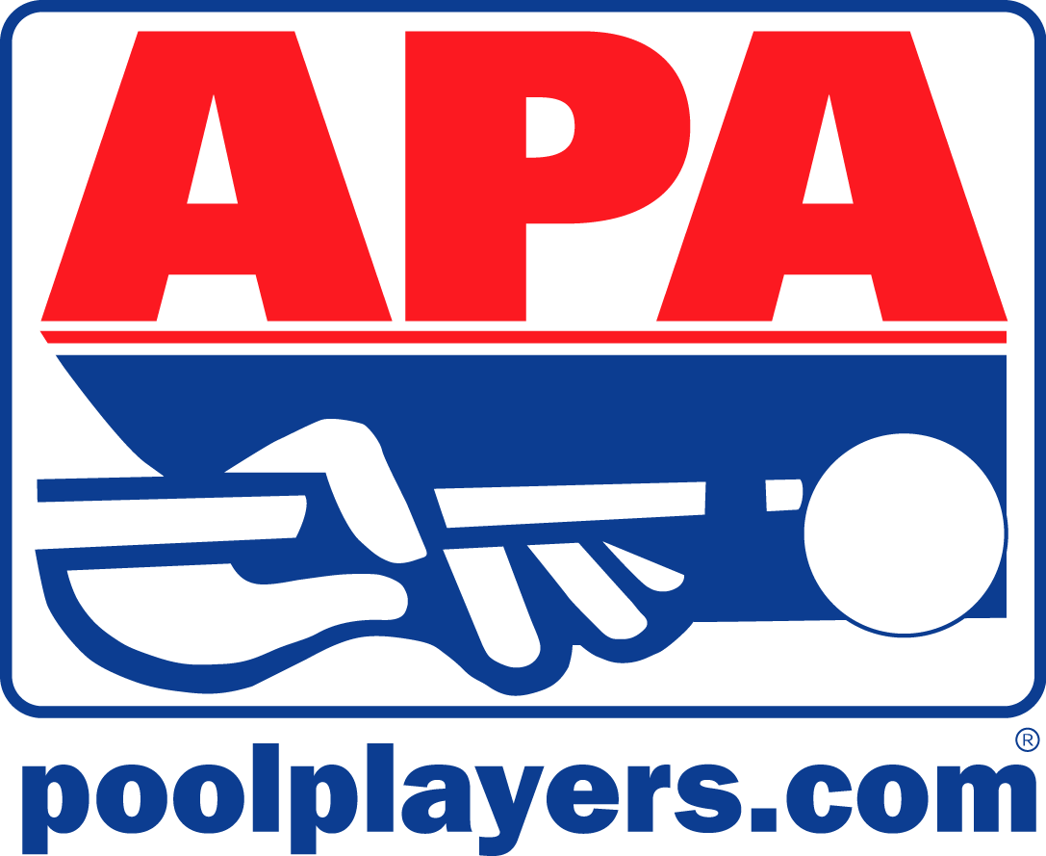

TOP GUN TOURNAMENT

The Top Gun Tournament for 8 Ball will be Sat. July 10th at
Murfreesboro Billiard Club

Doors open at 10 am on Sat. July 10th

Skill Levels 2’s & 3’s start at 10:30 am

Skill Level 4’s start at 1 pm

Skill Level 6’s start at 1 pm

Skill Level 5’s start at 3 pm

Skill Level 7’s start at 3 pm

Entry is $25

Top Gun Tournament for 9 Ball will be Sun. July 11th at
Murfreesboro Billiard Club

Doors open at 11 am on July 11th

All skill levels play at 11:30 am

Entry is $25

To secure your slot contact: Jen Martinez 691-0767

